***CS498 Applied Machine Learning HW1*** Name: Yu Che Wang / Netid: yuchecw2

**Three accuracies for 1A, 1B, 1D**

1A

accuracy_vec = [0.6493506 0.7337662 0.6753247 0.6688312 0.6883117 0.6883117 0.7272727 0.6948052 0.7142857 0.6428571]

⇒accuracy = 0.6883117

1B

accuracy_vec = [0.6428571 0.6883117 0.6688312 0.6753247 0.6818182 0.6493506 0.6103896 0.7272727 0.6493506 0.6038961]

⇒accuracy = 0.6597403

1D

 accuracy_vec = [0.6078431 0.7189542 0.6862745 0.6732026 0.6928105 0.6601307 0.6928105 0.6797386 0.6862745 0.6078431]

⇒accuracy = 0.6705882

**Code**

Evaluations

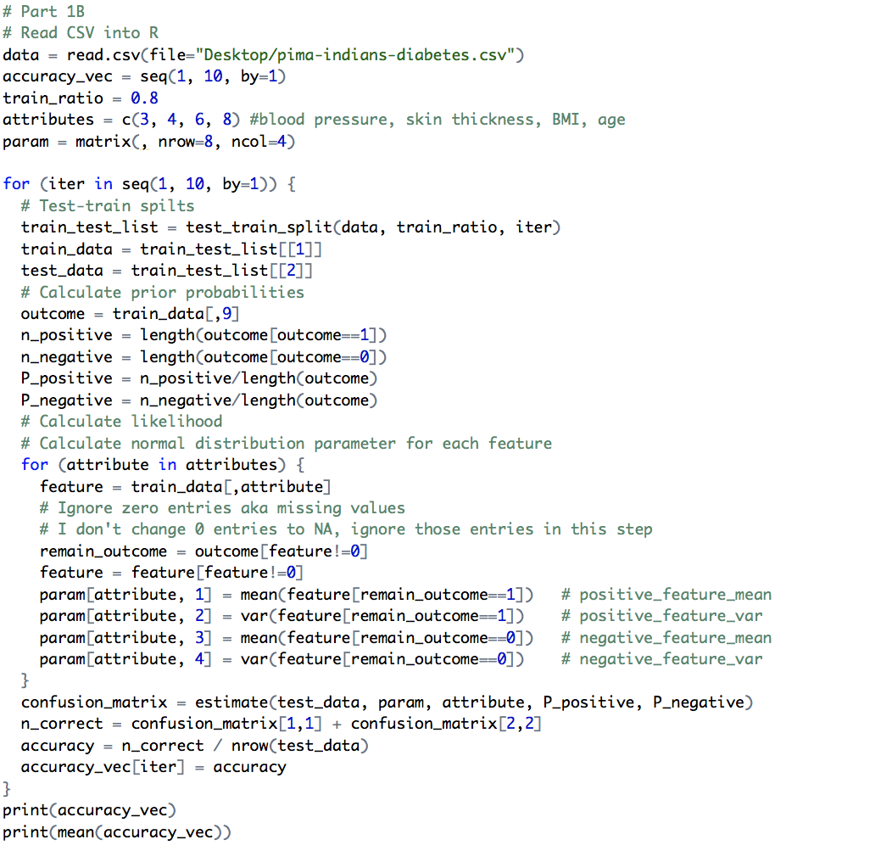

Probability calculations

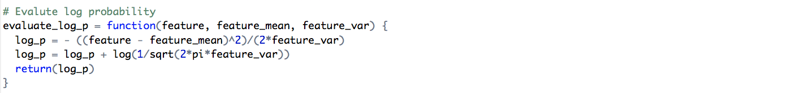

Calculating the confusion matrix and test-train split

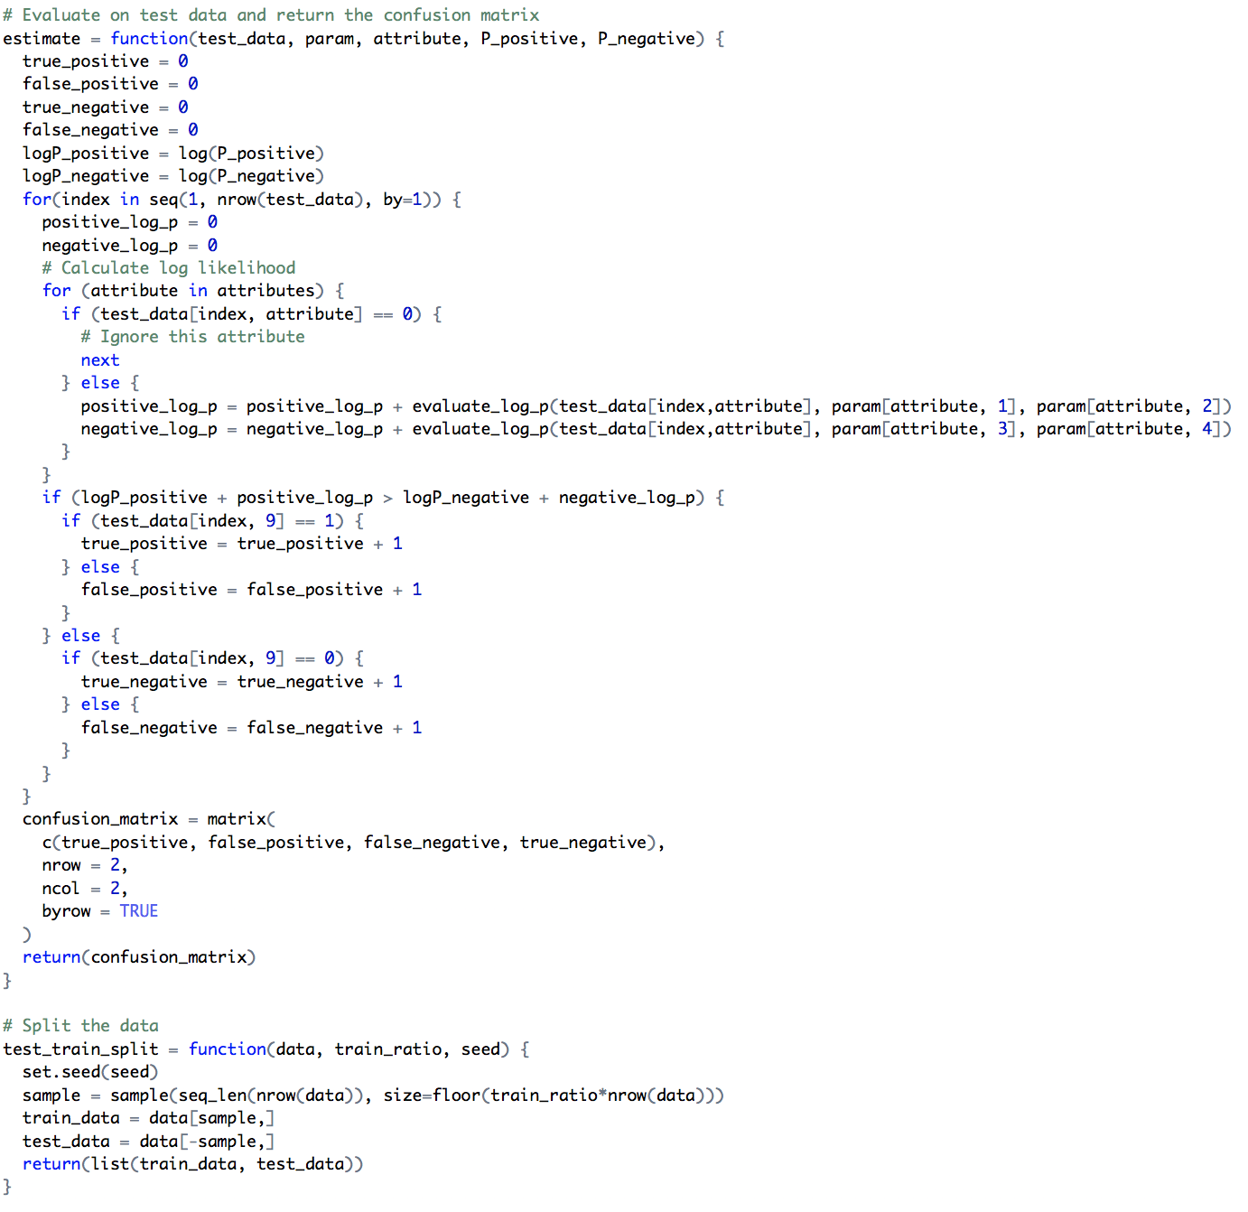

**Table of accuracies for all 12 cases**

Accuracies are obtained from validation

|  |  |  |
| --- | --- | --- |
|  | Model | Accuracy |
| 1 | Gaussian + untouched | 0.558107 |
| 2 | Gaussian + stretched | 0.811631 |
| 3 | Bernoulli + untouched | 0.833274 |
| 4 | Bernoulli + stretched | 0.810357 |
| 5 | 10 trees + 4 depth + untouched | 0.753107 |
| 6 | 10 trees + 4 depth + stretched | 0.751345 |
| 7 | 10 trees + 16 depth + untouched | 0.937464 |
| 8 | 10 trees + 16 depth + stretched | 0.942143 |
| 9 | 30 trees + 4 depth + untouched | 0.797893 |
| 10 | 30 trees + 4 depth + stretched | 0.784762 |
| 11 | 30 trees + 16 depth + untouched | 0.955452 |
| 12 | 30 trees + 16 depth + stretched | 0.958488 |

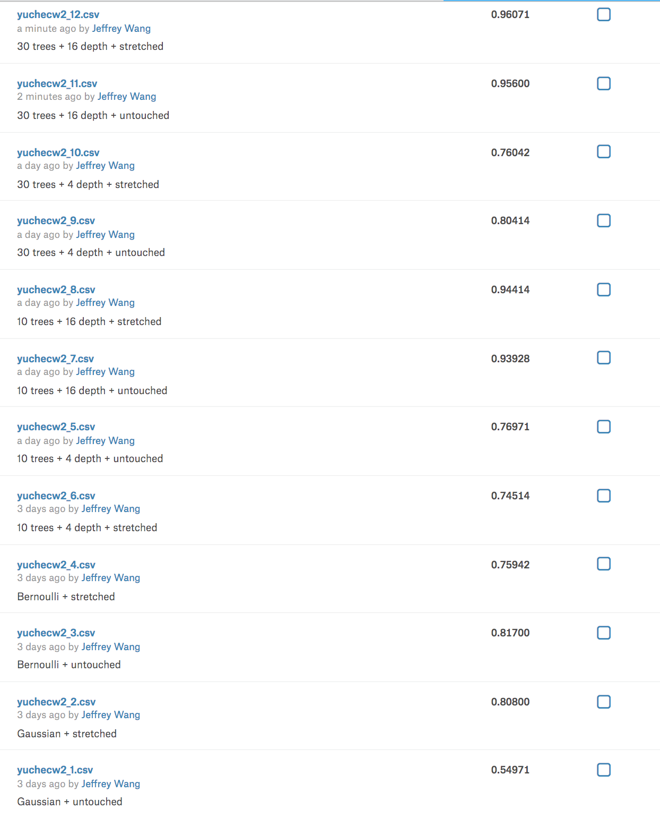

Random forest with 30 trees and 16 depth has the best performance since it detects more features.

**40 mean images**

1: Gaussian + untouched accuracy: 0.558107



2: Gaussian + stretched accuracy: 0.811631

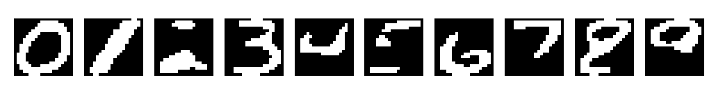

3: Bernoulli + untouched accuracy: 0.833274



4: Bernoulli + stretched accuracy: 0.810357



**Code**

Main function

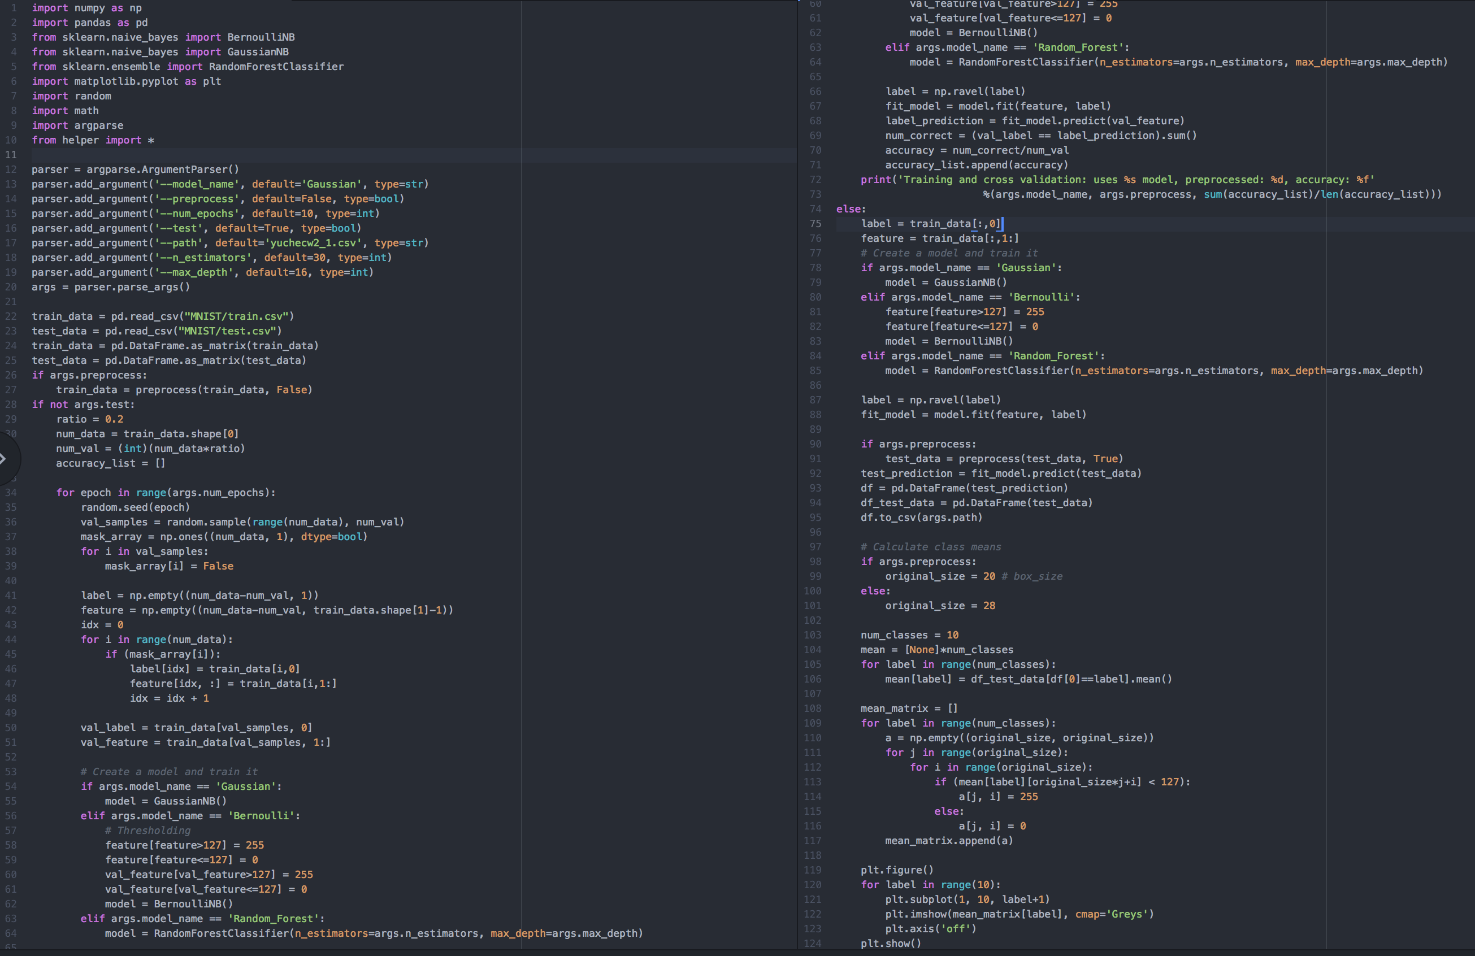

Helper functions

